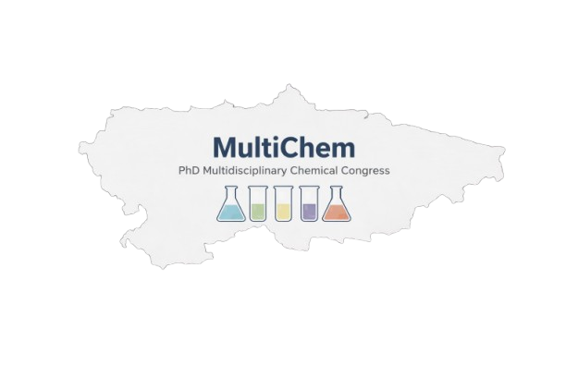
Title (13 pt)

(10 authors maximum) First name last name¹, First name last name², First name last name, First name last name (Arial 11,5 pt)

¹ University XXXXXXX, Research center xxxx (Arial 11,5 pt)
² University XXXXXXX, Research center xxxx (Arial 11,5 pt)
adsfadfasdfa@gmail.com

Keywords: (5 maximum) (Arial 11 pt)
The abstract should not exceed 300 words. The abstract should contain a brief introduction and the purpose of the research, materials and methods, results and main conclusions. The abstract should not exceed 300 words. The abstract should contain a brief introduction and the purpose of the research, materials and methods, results and main conclusions. The abstract should not exceed 300 words. The abstract should contain a brief introduction and the purpose of the research, materials and methods, results and main conclusions. The abstract should not exceed 300 words. The abstract should contain a brief introduction and the purpose of the research, materials and methods, results and main conclusions. The abstract should not exceed 300 words. The abstract should contain a brief introduction and the purpose of the research, materials and methods, results and main conclusions. The abstract should not exceed 300 words[1]. The abstract should contain a brief introduction and the purpose of the research, materials and methods, results and main conclusions. The abstract should not exceed 300 words. The abstract should contain a brief introduction and the purpose of the research, materials and methods, results and main conclusions[2]. The abstract should not exceed 300 words. The abstract should contain a brief introduction and the purpose of the research, materials and methods, results and main conclusions. The abstract should not exceed 300 words. The abstract should contain a brief introduction and the purpose of the research, materials and methods, results and main conclusions. The abstract should not exceed 300 words. The abstract should contain a brief introduction and the purpose of the research.
(Arial 11 pt)

Acknowledgments: (Arial 11 pt)
References: (5 maximum) (Arial 10.5 pt)
[1] L. Kelland, Nat. Rev. Cancer, 2007, 23, 573-584.
[2] D. L. Steven K. J. L. Lynda, Chem. Rev. 2000, 100, 1169-1204.

